# STRUCT.ai

> Real-time forex trading copilot — Smart Money Concepts analysis across 8 currency pairs and 4 timeframes, streaming live from MetaTrader 5 to a FastAPI backend and a React dashboard.

![STRUCT.ai dashboard](docs/screenshots/dashboard.png)

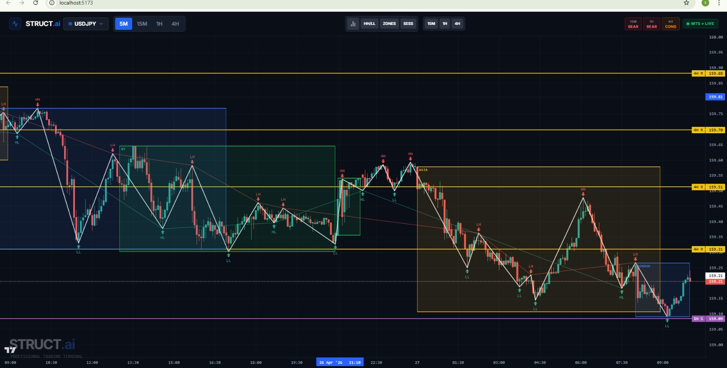
---

## What it does

STRUCT.ai is a **manual-trading copilot**. It does not place orders for you. Instead, it watches the market in real time and shows the structural information you would otherwise have to draw by hand — swing points, market structure (HH / LH / HL / LL), break-of-structure events, multi-timeframe support and resistance, trading sessions, and trend bias on every timeframe at once.

Built for a discretionary intraday workflow on USD/JPY, GBP/USD, EUR/USD, EUR/JPY and GBP/JPY, on the 5M / 15M / 1H / 4H timeframes simultaneously.

---

## Architecture

```
┌──────────────────────────┐
│ MetaTrader 5 Terminal │
│ (your broker, Windows) │
└─────────────┬────────────┘
│ reads OHLC every 30s
▼
┌──────────────────────────┐
│ MT5 Bridge │
│ Python script (local) │
└─────────────┬────────────┘
│ HTTP POST /trading-api/mt5/push
▼
┌────────────────────────────────────────────────┐
│ FastAPI Backend │
│ ┌──────────┐ ┌──────────┐ ┌──────────┐ │
│ │ ZigZag │ │ Structure│ │ Trend │ │
│ │ engine │ │ engine │ │ engine │ │
│ └──────────┘ └──────────┘ └──────────┘ │
│ ┌──────────┐ ┌──────────┐ ┌──────────┐ │
│ │ BOS │ │ CHOCH │ │ MTF S/R │ │
│ │ engine │ │ engine │ │ engine │ │
│ └──────────┘ └──────────┘ └──────────┘ │
│ ┌──────────┐ ┌──────────┐ ┌──────────┐ │
│ │ Sessions │ │ Zones │ │Trendline │ │
│ └──────────┘ └──────────┘ └──────────┘ │
│ │
│ Twelve Data API ← fallback if MT5 offline │
└─────────────────────┬──────────────────────────┘
│ REST + WebSocket
▼
┌────────────────────────────┐
│ React Dashboard │
│ TradingView Lightweight │
│ Charts v5 │
└────────────────────────────┘
```

---

## Tech stack

| Layer | Stack |
|---|---|
| **Backend** | Python 3.11, FastAPI, Pandas, NumPy, httpx, WebSockets |
| **Frontend** | React 18, TypeScript, Vite, TailwindCSS, shadcn/ui, TradingView Lightweight Charts v5, TanStack Query |
| **Bridge** | Python, MetaTrader5 SDK, requests |
| **Data sources** | MetaTrader 5 (primary), Twelve Data API (fallback) |
| **Tooling** | pnpm (frontend), pip (backend), Windows .bat one-click launcher |

---

## Screenshots

| | |
|---|---|
| ![Dashboard](docs/screenshots/dashboard.png) | ![Launcher console](docs/screenshots/launcher.png) |
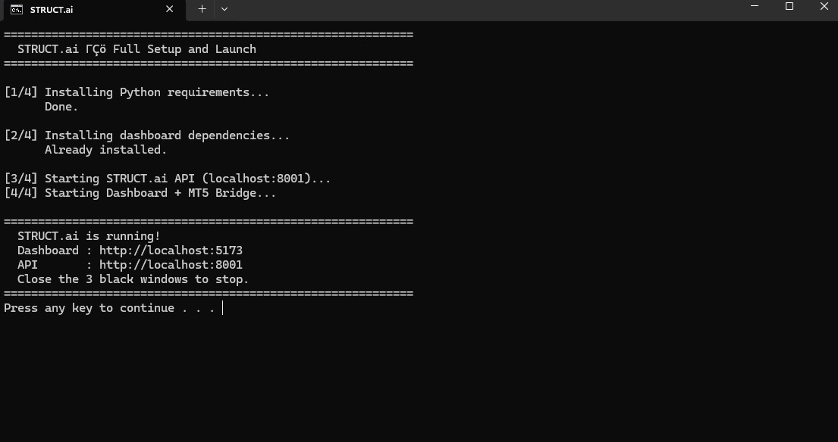
| Main dashboard with multi-timeframe bias and S/R | One-click Windows launcher |
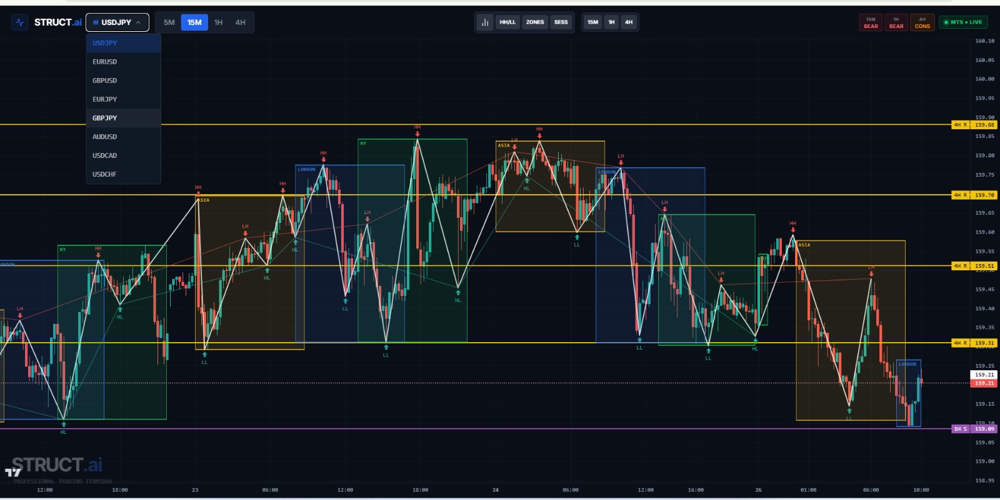

| ![MT5 bridge log](docs/screenshots/mt5-bridge.png
)

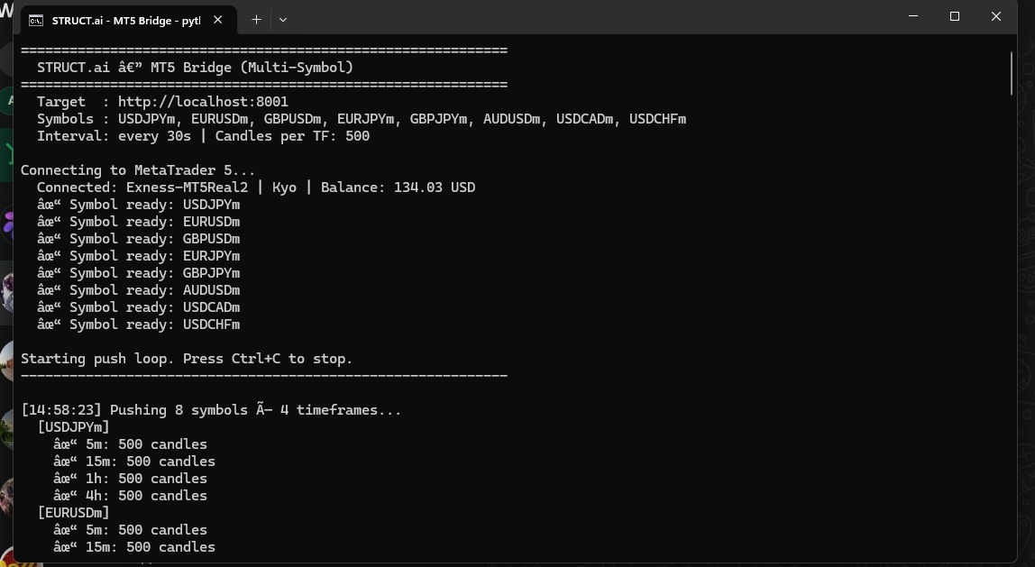

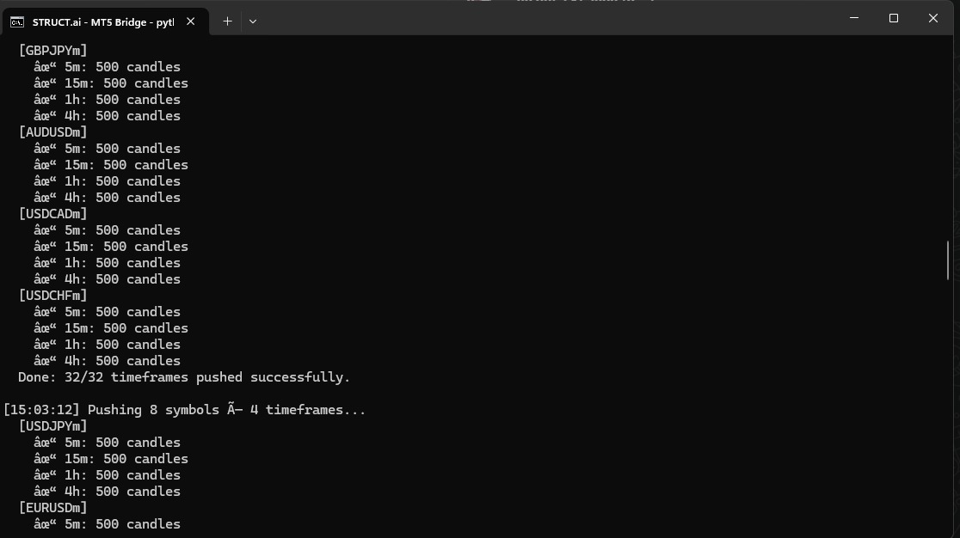

| ![API server log](docs/screenshots/api-server.png) |

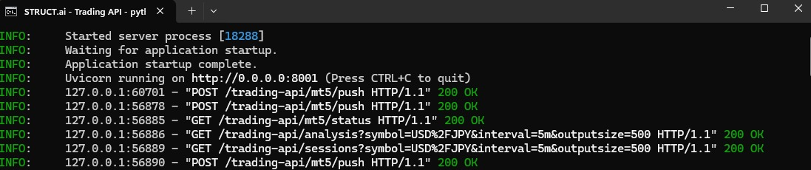

| MT5 bridge pushing 5 symbols × 4 timeframes | FastAPI server processing structure analysis |

---

## Quick start (Windows)

**Prerequisites:**
- Windows 10 or 11
- Python 3.11 or higher
- Node.js 20 or higher
- pnpm (`npm install -g pnpm`)
- MetaTrader 5 installed and logged in to your broker (live or demo)

**Steps:**

1. Clone the repo
```
git clone https://github.com/<your-username>/struct-ai.git
cd struct-ai
```

2. Copy the env template and add your Twelve Data API key (free tier works)
```
copy .env.example .env
notepad .env
```

3. Open MetaTrader 5 and log in to your account. Make sure the symbols you want (USD/JPY, EUR/USD, etc.) are visible in the Market Watch panel.

4. Double-click `launcher/STRUCT-AI.bat`

This installs everything and starts three windows:
- The FastAPI backend (`http://localhost:8001`)
- The MT5 bridge (pushing candles every 30 seconds)
- The React dashboard (`http://localhost:5173`)

5. The dashboard opens automatically in your default browser.

To stop everything, close the three black console windows.

---

## Project structure

```
struct-ai/
├── backend/ Python FastAPI
│ ├── main.py App entry, CORS, routers, WebSocket
│ ├── requirements.txt
│ ├── routers/ HTTP endpoints
│ │ ├── data.py Raw OHLC
│ │ ├── mt5.py MT5 bridge push + status
│ │ └── structure.py Analysis endpoints (bias, S/R, sessions)
│ ├── services/ Analysis engines
│ │ ├── data_service.py MT5-primary, Twelve Data fallback
│ │ ├── mt5_store.py In-memory candle store
│ │ ├── zigzag_engine.py Strict-alternation swing detection
│ │ ├── structure_engine.py HH / LH / HL / LL classification
│ │ ├── trend_engine.py Per-timeframe trend bias
│ │ ├── trendline_engine.py Diagonal trendlines
│ │ ├── bos_engine.py Break of Structure
│ │ ├── choch_engine.py Change of Character
│ │ ├── mtf_sr_engine.py Multi-timeframe S/R with flip
│ │ ├── session_engine.py Asian / London / NY session boxes
│ │ └── zones_engine.py Demand / supply zones
│ └── mt5-bridge/
│ └── mt5_bridge.py Windows-only MT5 → API push script
│
├── frontend/ React + Vite dashboard
│ ├── package.json
│ ├── vite.config.ts
│ ├── index.html
│ └── src/
│ ├── App.tsx
│ ├── pages/Dashboard.tsx
│ ├── components/
│ │ ├── TradingChart.tsx Candlestick + ZigZag + S/R + sessions
│ │ ├── TopBar.tsx Bias chips, symbol/timeframe selector
│ │ └── ui/ shadcn/ui primitives
│ └── hooks/
│ └── use-trading-api.ts TanStack Query hooks
│
├── launcher/ Windows .bat one-click scripts
│ ├── STRUCT-AI.bat Main launcher (installs + starts everything)
│ ├── start_api.bat Backend only
│ ├── start_bridge.bat MT5 bridge only
│ └── install_requirements.bat
│
├── docs/
│ ├── STRUCT-AI-Full-Documentation.md
│ └── screenshots/
│
├── ARCHITECTURE.md
├── .env.example
├── .gitignore
├── LICENSE
└── README.md
```

---

## API endpoints

All endpoints are mounted under the `/trading-api` prefix.

| Method | Endpoint | Purpose |
|---|---|---|
| GET | `/health` | Liveness check |
| GET | `/analysis` | Candles + ZigZag swings + structure labels + trend |
| GET | `/sr-levels` | Multi-timeframe support / resistance levels |
| GET | `/mtf-bias` | Trend bias per timeframe (BULL / BEAR / CONS) |
| GET | `/sessions` | Asian / London / NY session boxes |
| GET | `/mt5/status` | Whether the MT5 bridge is currently online |
| POST | `/mt5/push` | Bridge endpoint — receives OHLC candles from MT5 |
| WS | `/ws` | Live price stream over WebSocket |

---

## How the engines work (short version)

- **ZigZag engine** — detects swing highs and lows with strict high → low → high alternation, so the structure is always clean.
- **Structure engine** — labels each swing as HH (higher high), LH (lower high), HL (higher low), or LL (lower low) using the standard market-structure definition.
- **Trend engine** — looks at the last confirmed HH/LH and HL/LL pair to decide bullish, bearish, or consolidation per timeframe.
- **MTF S/R engine** — extracts support and resistance from 15M, 1H and 4H, applies the S/R flip rule (resistance is always above price, support always below), and filters by proximity.
- **BOS / CHOCH engines** — detect break-of-structure and change-of-character events that signal trend continuation or reversal.
- **Session engine** — overlays the Asian (00–09 UTC), London (08–17 UTC), and New York (13–22 UTC) sessions, including their natural overlap windows.

---

## Environment variables

| Variable | Required | Purpose |
|---|---|---|
| `TWELVE_DATA_API_KEY` | recommended | Fallback market data when MT5 is offline. Free tier: 8 credits/min |
| `MT5_BRIDGE_SECRET` | optional | Shared secret between bridge and API. If empty, validation is skipped (dev mode) |
| `TRADING_API_PORT` | optional | Defaults to `8001` |

Copy `.env.example` to `.env` and fill in the values. The launcher loads them automatically.

---

## Status and roadmap

**Phase 1 — Rule-based market structure dashboard — ✅ Complete**
- Live candles across 5 pairs × 4 timeframes
- ZigZag swings with strict alternation
- HH / LH / HL / LL structure labels
- Multi-timeframe trend bias chips
- Multi-timeframe S/R with flip and proximity filtering
- Session overlays
- MT5 primary data source with Twelve Data fallback
- Rate-limit protection (in-flight deduplication + retry backoff)
- One-click Windows launcher

**Known issues** — see [docs/STRUCT-AI-Full-Documentation.md](docs/STRUCT-AI-Full-Documentation.md) for the full list and recommended fixes.

**Phase 2 (planned)** — AI assistant layer, signal scoring, trade-setup suggestions.

---

## A note on origin

This project was built in roughly 3 days as an AI-assisted prototype to explore what a personal trading copilot could look like. The architecture, engine logic, and integration design are documented above; the implementation was iterated heavily with AI tooling. It is shared publicly for transparency, learning, and as a working reference for anyone building similar Smart Money Concepts tools.

The code is not production trading infrastructure. It is a research and learning artifact. Use it accordingly.

---

## License

MIT — see [LICENSE](LICENSE).

## Contact

Built by Azaan Ul Haq — Software Engineering student, International Islamic University Islamabad.

If you're using STRUCT.ai or building something similar, I'd love to hear about it.

